Itinerary Breakdown
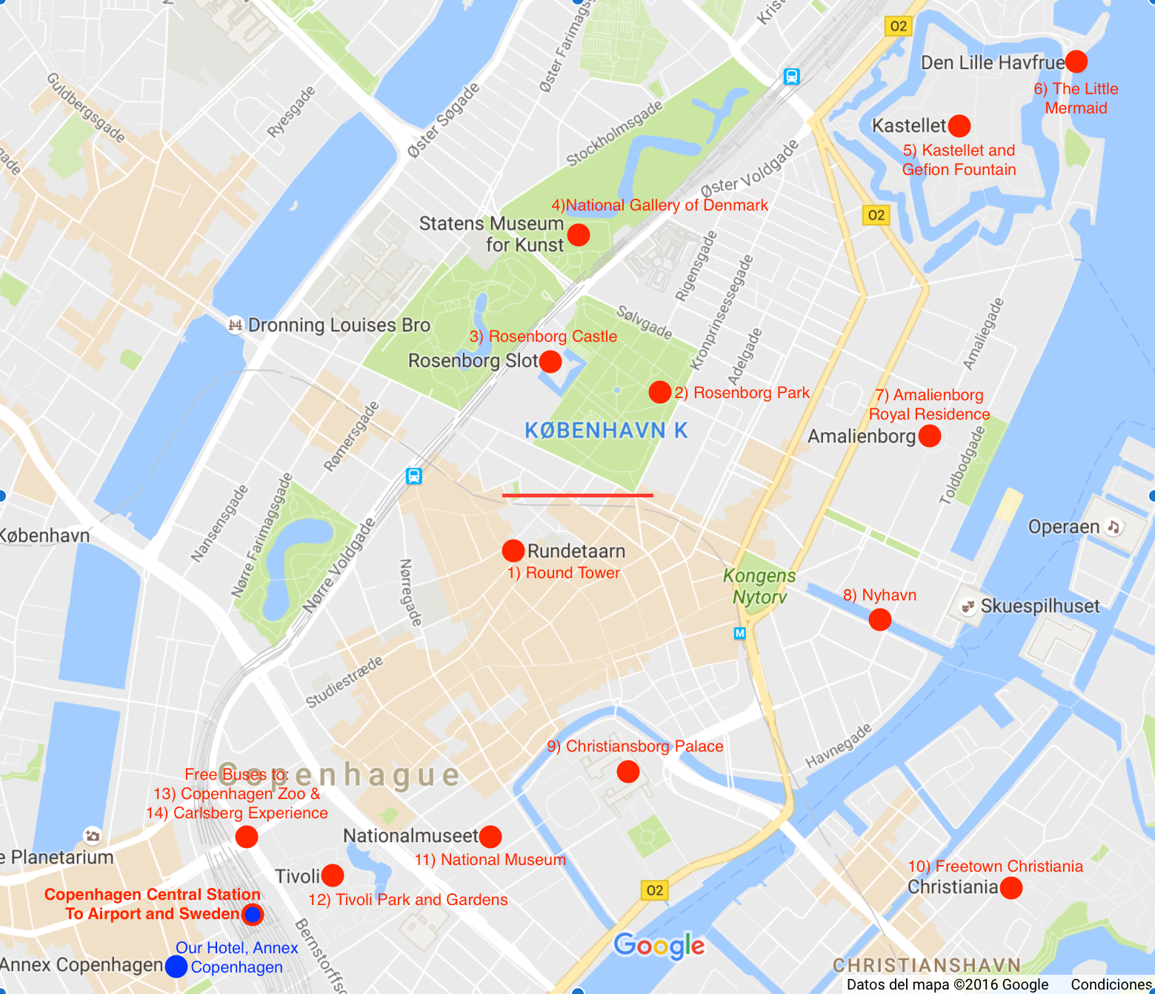
Friday | Saturday | Sunday
Arrived Copenhagen Airport 1pm | City Hall Square | Changing of the Guard 12noon
Checked In Annex Copenhagen | Our Lady Church (Vor Frue Kirke) | Food at China Box
Walked around Vesterbro | Round Tower | Carlsberg Experience
Walked along banks of The Lakes | Kings Garden (Rosenborg Park) | Freetown Christiania
Food at Jagger | Rosenborg Slot (Castle) | Flew out of Copenhagen Airport
 | Kastellet
 | The Little Mermaid Statue
 | Gefion Fountain
 | Marble Church (Frederiks Kirke)
 | Amelienborg Palace and Gardens
 | Food at Duck It! Food Truck
 | Nyhavn and Kongens Nytorv
 | Christiansborg Slot (Palace)

